[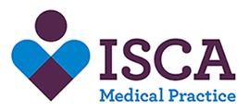](https://www.iscamp.co.uk/)

**PLEASE NOTE:** We want to confirm thatduring the period of covid-19 all primary care services (GP practices, dental practices, pharmacies and optometry providers) **will** **remain open to treat patients in line with their standard operating procedures, offering care which is safe, necessary and clinically prioritised**.

**September Newsletter**

Please continue to wear your masks in the surgery; this is to continue protecting yourself and those who are vulnerable around you.



We would like to welcome some new members of staff to the surgery:

Dr Nigel De Sousa – will be joining us as a salaried GP in September working three days a week.

Anna – joined the surgery as our apprentice and will be working alongside the admin team.

Pat – joined the surgery as an administrator working in the administration department.



At present we are updating our telephone system. We apoligise if you experience any issues whilst trying to get through to us. This is an issue we are aware off and ask if you could be patient whilst this issue is resolved. Thank you for your understanding.

Make an appointment to speak to one of our nurses to help stop smoking.

If you would like to join our friends of Isca group and make a difference to your surgery please contact Richard Westlake on rawestlake@phonecoop.coop



**Thank you!**

We would like to send a huge thank you to the friends of Isca who raised money by selling books and chutney to purchase some baby scales for the surgery.

Why not have a go at colouring in!



Are you 65+ - why not book in for a pneumonia vaccine to protect against severe Pneumococcal infections. This is a one off vaccination. Call the surgery today to book yours in.

**Covid Boosters:**

We are still waiting to hear from NHS England in regards to you receiving your covid booster. We will be in contact with you as soon as we have more information.

**If you are phoning for test results please ensure this is between 2pm and 4pm. Thank you**

GET YOUR FLU SHOT:

It is that time a year again where flu season is upon us. We have the following clinics available:

**Under 65 (With Underlying conditions):**

* 14th September 2021
* 15th Septmber
* 16th September 2021
* 5th October

**Over 65:**

* 25th September
* 28th September



Goodbye and Goodluck



Unfortunately our Lead Nurse Megan is leaving us to go and work in another surgery, Thank you Megan you have been amazing. Good luck with everything

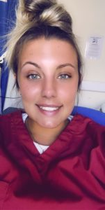

Morrigan who many will have had your blood taken by, is also leaving us to attend University, this is where she will be completing her nursing degree. Good luck Morrigan, All the best.