Continuity Counts Patient Survey Comms:
Social Media and Website Content
Here at [Insert practice name], we have been working hard to make it easier for you to see your preferred GP, if you have one.
It would be great to hear your views on this and understand what is important to you. If you can spare five minutes, please complete the following survey: https://forms.office.com/r/0cGDKwhy3H
Your practice has been working hard to make it easier for you to see your preferred GP, if you have one.
It would be great to hear your views on this and understand what is important to you.
Take part in our survey.

Text message and ‘bounceback’ content
We have been working hard to make it easier for you to see your preferred GP, if you have one. Please share your views on this and to help us understand what is important to you: https://forms.office.com/r/0cGDKwhy3H

Email content for PPG/ Patient Champions
Subject: Increasing Continuity of Care in General Practice
Dear [insert name],
Your practice has been working hard to make it easier for you to see your preferred GP, if you have one. It would be great to hear your views on this and understand what is important to you. If you can spare five minutes, please complete the following survey: https://forms.office.com/r/0cGDKwhy3H
The results of the survey will be used as part of The Health Foundation’s study on continuity of care which your practice has been part of. If you have any queries about the survey, please contact emma.sheridan@mottmac.com.
Many thanks,
[appropriate sender] – PM/ MM
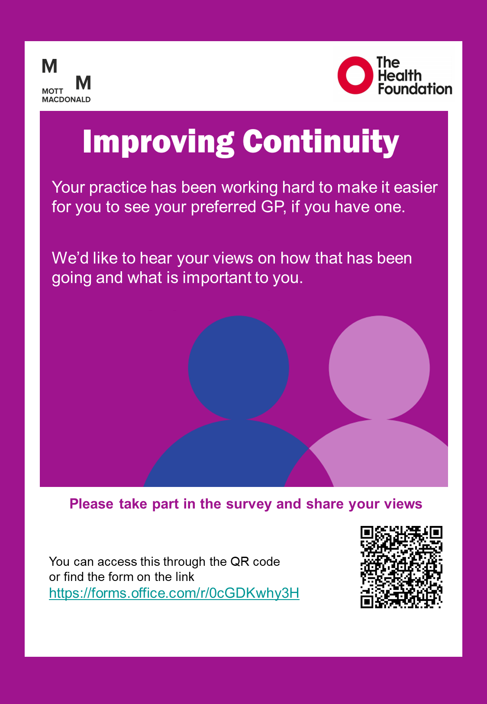

Staff Survey Comms:
Email content for Practice Staff
Subject: Increasing Continuity of Care in General Practice
Dear [insert name],
You and your practice have been working hard to make it easier for patients to see your preferred GP, if they have one. It would be great to hear how that process has been going, how successful you think it has been and what is important to you. To provide this insight, could you kindly complete the following survey: https://forms.office.com/r/14vQ0B15r7
This will take around ten minutes to complete and all responses will be anonymous. The results of the survey will be used as part of The Health Foundation’s study on continuity of care which your practice has been part of. If you have any queries about the survey, please contact emma.sheridan@mottmac.com.
Many thanks,
[appropriate sender] – PM/ MM
Content for Staff Newsletter You and your practice have been working hard to make it easier for patients to see your preferred GP, if they have one. It would be great to hear how that process has been going, how successful you think it has been and what is important to you. To provide this insight, could you kindly complete the following survey: https://forms.office.com/r/14vQ0B15r7
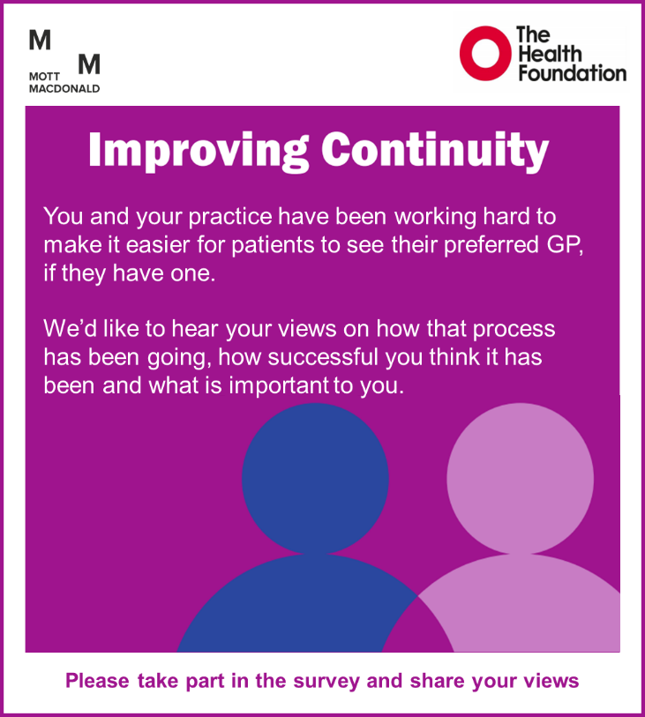
This will take around ten minutes to complete and all responses will be anonymous. The results of the survey will be used as part of The Health Foundation’s study on continuity of care which your practice has been part of. If you have any queries about the survey, please contact emma.sheridan@mottmac.com.

