New Patient Registration Form Please complete all pages in full using block capitals

1. Background Details

Contact Details
Name |  |  | Gender
NHS Number
Address |  |  | Date of Birth
Address |  |  | Home Telephone
Address |  |  | Work Telephone
Mobile Telephone
Email
Next of Kin | Name: | Tel: |  | Relationship:
* It is your responsibility to keep us updated with any changes to your telephone number, email & postal address.
We may contact you with appointment details, test results or health campaigns
If you do not consent to being contacted by SMS or Email, please tick here: SMS Email

Other Details
Previous GP | Name: |  | Address:
Country of Birth
Ethnicity | White (UK)  White (Irish)  White (Other) | Black Caribbean  Black African  Black Other |  | Bangladeshi  Indian  Pakistani | Chinese  Other
Religion | C of E  Catholic  Other Christian | Buddhist  Hindu  Muslim |  | Sikh  Jewish  Jehovah’s Witness | No religion  Other:
Occupation

Communication Needs
Language | What is your main spoken language?  Do you need an interpreter? Yes No
Communication | Do you have any communication needs? Yes No (If Yes please specify below)
Communication | Hearing aid  Lip reading | Large print  Braille | British Sign Language  Makaton Sign Language Guide dog

Carer Details
Are you a carer? | Yes – Informal / Unpaid Carer |  | Yes – Occupational / Paid Carer |  | No
Do you have a carer? | Yes | Name*: | Tel: | Relationship:
* Only add carer’s details if they give their consent to have these details stored on your medical record

Armed Forces | Military Veteran | Family member

2. Medical History

Medical History
Have you suffered from any of the following conditions?
Asthma  COPD  Epilepsy | Heart Disease  Heart Failure  High Blood Pressure | Diabetes  Kidney Disease  Stroke | Depression  Underactive Thyroid  Cancer- Type:
Any other conditions, operations or hospital admission details:

If you are currently under the care of a Hospital or Consultant outside our area, please tell us here:

Family History
Please record any significant family history of close relatives with medical problems and confirm which relative e.g. mother, father, brother, sister, grandparent

Asthma………………….  COPD………………...…  Epilepsy………………… | Heart Disease……….…  Stroke…………….……..  Blood Pressure………… | Diabetes………..………  Kidney Disease..………  Liver Disease..….…….. | Depression………..……  Thyroid…………..….…..  Cancer…………………..
Other:

Allergies
Please record any allergies or sensitivities below

Current Medication
Please check and include as much information about your current medication below
Please give us your previous repeat medication list if possible and a medication review appointment may be needed

3. Your Lifestyle

Alcohol
Please answer the following questions which are validated as screening tools for alcohol use:

AUDIT–C QUESTIONS | Scoring System |  |  |  |  | Your Score
AUDIT–C QUESTIONS | 0 | 1 | 2 | 3 | 4 | Your Score
How often do you have a drink containing alcohol? | Never | Monthly or Less | 2-4 times per month | 2-3 times per week | 4+ times per week
How many units of alcohol do you drink on a typical day when you are drinking? | 1-2 | 3-4 | 5-6 | 7-9 | 10+
How often have you had 6 or more units if female, or 8 or more if male, on a single occasion in the last year? | Never | Less than monthly | Monthly | Weekly | Daily or almost daily
A score of less than 5 indicates lower risk drinking |  |  |  |  | TOTAL:
Scores of 5 or more requires the following 7 questions to be completed:
AUDIT QUESTIONS  (after completing 3 AUDIT-C questions above) | Scoring System |  |  |  |  | Your Score
 | 0 | 1 | 2 | 3 | 4 | Your Score
How often during the last year have you found that you were not able to stop drinking once you had started? | Never | Less than monthly | Monthly | Weekly | Daily or almost daily
How often during the last year have you failed to do what was normally expected from you because of your drinking? | Never | Less than monthly | Monthly | Weekly | Daily or almost daily
How often during the last year have you needed an alcoholic drink in the morning to get yourself going after a heavy drinking session? | Never | Less than monthly | Monthly | Weekly | Daily or almost daily
How often during the last year have you had a feeling of guilt or remorse after drinking? | Never | Less than monthly | Monthly | Weekly | Daily or almost daily
How often during the last year have you been unable to remember what happened the night before because you had been drinking? | Never | Less than monthly | Monthly | Weekly | Daily or almost daily
Have you or somebody else been injured as a result of your drinking? | No |  | Yes, but not in last year |  | Yes, during last year
Has a relative or friend, doctor or other health worker been concerned about your drinking or suggested that you cut down? | No |  | Yes, but not in last year |  | Yes, during last year
 |  |  |  |  | TOTAL:
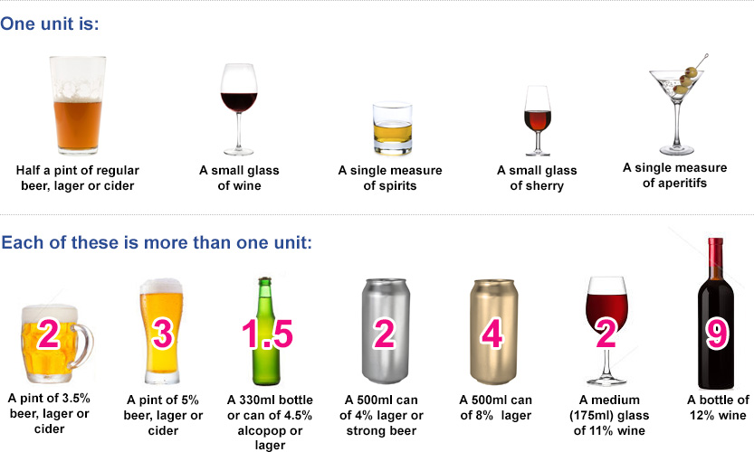

3. Your Lifestyle - Continued

Smoking
Do you smoke? | Never smoked | Ex-smoker | Yes
Do you use an e-Cigarette? | No | Ex-User | Yes
How many cigarettes did/do you smoke a day? | Less than one | 1-9 10-19 | 20-39 40+
Would you like help to quit smoking? | Yes | No
 | For further information, please see: www.nhs.uk/smokefree

Students Only
Students are at risk of certain infections including mumps, meningitis and sexually transmitted infections, as well as mental health issues including stress, anxiety and depression. Please see www.nhs.uk/Livewell/Studenthealth
I am less than 24 years old and have had two doses of the MMR Vaccination | Yes | No | Unsure
I am less than 25 years old and have had a Meningitis C Vaccination | Yes | No | Unsure

4. Further Details

Electronic Prescribing
If you would like your prescriptions to be sent electronically,  please provide details of the pharmacy you would like to use: | Pharmacy:

Blood and Organ Donation
Blood Donation | I am already a blood donor  I wish to be a blood donor  I do not wish to be a blood donor
Organ Donation | I am already registered as a donor  I wish to be a donor – all body part  I wish to be a donor – for these body parts:  I do not wish to be a donor  To register: Online: www.blood.co.uk/the-donation-process/recognising-donors  Telephone: 0300 123 23 23 to speak to an advisor who will send out a donor card.

Signatures
Signature | I confirm that the information I have provided is true to the best of my knowledge.  Signed on behalf of patient
Name
Date

I wish to have online access to: Please tick all that apply
View & book appointments
View & request medication
Access my coded medical record (contains any medical codes that have been recorded)
Access my full medical record (contains medical codes and any free text that has been recorded)
Access my Summary Care Record
Complete online questionnaires

I wish to access my medical record & understand & agree with each statement: Please tick all that apply
I will be responsible for the security of the information that I see or download
If I choose to share my information with anyone else, this is at my own risk
I will contact the practice as soon as possible if I suspect that my account has been accessed by someone without my agreement
If I see information in my record that it not about me, or is inaccurate I will log out immediately and contact the practice as soon as possible

Please bring photographic proof of your identification in order for the sign up process to be completed

Signature
Signature
Name
Date

For Practice Use Only:
Identity verified through  (tick all that apply) | Self Vouching  Vouching with information in record  Photo ID  Proof of residence  Professional Vouching
Name of Verifier |  | Date
Name of person who authorised and added to SystmOne |  | Date
Photocopied this page | Yes – Name:
Passed for scanning | Yes – Name:

5. Sharing Your Health Record

Your Health Record
Do you consent to your GP Practice sharing your health record with other organisations who care for you?

Yes (recommended option)
No, never

Do you consent to your GP Practice viewing your health record from other organisations that care for you?

Yes (recommended option)
No

Your Summary Care Record (SCR)
Do you consent to having an Enhanced Summary Care Record with Additional Information?

Yes (recommended option)
No

Signature
Signature
Signed on behalf of patient
Name
Date

For more information on sharing your health record, online access and GDPR please ask reception.

