[](https://www.iscamp.co.uk/)

**PLEASE NOTE:** We want to confirm thatduring the period of tighter restrictions all primary care services (GP practices, dental practices, pharmacies and optometry providers) **will** **remain open to treat patients in line with their standard operating procedures, offering care which is safe, necessary and clinically prioritised**.

**November Newsletter**

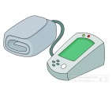

With the festive season rapidly approaching we just wanted to remind you the ways of ordering medication to ensure medication is received in a timely manner. Please order medication by the following:

* Online services (Please see our admin team if you require a username and password)
* Via a printed version of your repeat prescription (This can be dropped in the post box at the surgery or posted via royal mail)
* Via your nominated pharmacy who can order on your behalf.

Please note: we do not take medication requests over the telephone!

What’s happening outside of the surgery?:

* World COPD day – 18th November 2020
* Alcohol Awareness Week – 16th -22nd November 2020
* Carers rights day – 26th November 2020
* 16 days of action – 25th November- 10th December 2020.

Please Note: we are going to have repairs on our roof, please be careful when walking around the site.

We would like to welcome our medical students who may be assisting the doctors with their consultations.

Our Blood Pressure machine is now available for patients to use again, at a time convenient for you. Please just ask our admin team for assistance.

Isca Medical Practice Friends have been extremely busy in updating our book collection as well as crocheting poppies available to purchase in the waiting room for £1. Why not delve yourself into a good book and place a donation into our donation pot. “A book is a dream that you hold in your hand” – Neil Gaiman. So we would like to say a massive thank you for that!

**During these unprecedented times our phone lines are extremely busy, if you are on the phone to our admin team, we may ask you some triage questions to assess the urgency of your call. An alternate option would be to complete an e-consultation on our website where a response is given via text message within 48 hours.**

**The vaccination for 50-64 year olds with no underlining health conditions will be available from December.**

**Flu Clinics:**

We are still able to offer flu vaccinations to over 65s, under 65s with long term conditions and pregnant women. If you are unsure whether you are eligible please contact the surgery on 01392273805 as well as booking one in. Our available clinics are:

* Friday 13th November ( Over 65s) Limited spaces
* Monday 16th November (Under 65s)
* Friday 27th November (Over 65)

**Please wear a face mask when entering and walking around the surgery!**

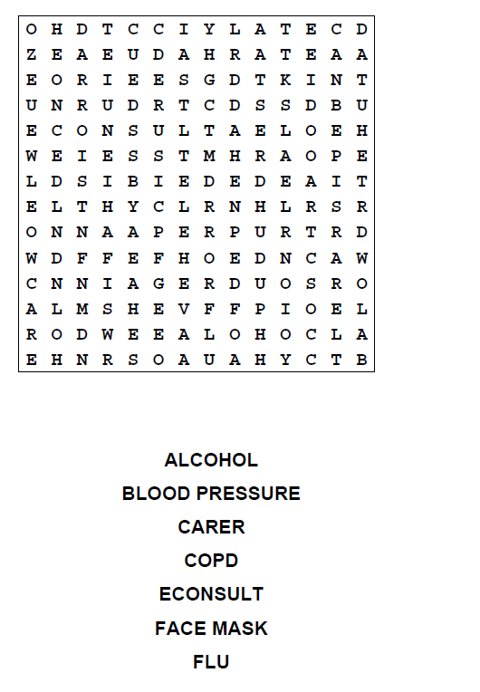[](https://www.iscamp.co.uk/)







Why not have a go at colouring in!