[](https://www.iscamp.co.uk/)

**PLEASE NOTE:** We want to confirm thatduring the period of tighter restrictions all primary care services (GP practices, dental practices, pharmacies and optometry providers) **will** **remain open to treat patients in line with their standard operating procedures, offering care which is safe, necessary and clinically prioritised**.

**December Newsletter**



Are you over 65? Under65 with underlining health conditions or Pregnant – then call the surgery on 01392273805 to book your flu vaccine in.

Find out if you should have a pneumonia vaccination, by contacting 01392273805 to arrange to speak to our lovely nurses. Check if your eligible through https://www.nhs.uk/conditions/vaccinations/pneumococcal-vaccination/

**Whilst we are closed if you require assistance in an emergency please call 999 or for any medical advice call 111**

**Opening and closing hours over the festive period:**

* 24th December – 8:30am – 6:00pm
* 25th December – Closed
* 26th December – Closed
* 27th December – Closed
* 28th December – Closed.
* 29th December – 8:30am – 6:00pm
* 30th December – 8:30am-6:00pm
* 31st December – 8:30am-6:00pm
* 1st January – closed
* 2nd January – closed
* 3rd January – closed
* 4th January – 8:30am – 6:00pm

We would like to welcome Dr Amy Brighton who is our new registrar. We would also like to welcome all of our medical students who may be assisting the doctors.

We are unaware of any details relating to the coronavirus vaccination, we are waiting for details of when and where, as soon as we know… we will let you know.

**Did someone say Covid vaccine?**

With the festive season rapidly approaching we just wanted to remind you the ways of ordering medication to ensure medication is received in a timely manner. Please order medication by the following:

* Online services (Please see our admin team if you require a username and password)
* Via a printed version of your repeat prescription (This can be dropped in the post box at the surgery or posted via royal mail)
* Via your nominated pharmacy who can order on your behalf.

Please note: we do not take medication requests over the telephone!

Are you 50 – 64 and would like a flu jab for FREE. Call 01392273805 to be booked in.



We wish you all a healthy and happy Christmas, from all the staff at Isca Medical Practice.

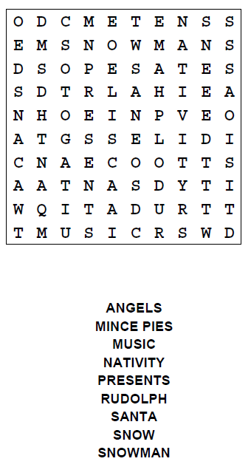





Why not have a go at colouring in!