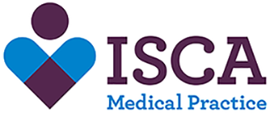
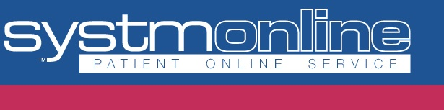

Online appointment booking
Important update
We have been advised to suspend our service for booking appointments online. We have replaced these appointments with our e consult service and this service can we accessed via out website www.iscamp.co.uk it’s a great set of online tools for you to check which service is right for your symptoms, get immediate self-help advice and manage certain conditions, without the need to attend the surgery in person.
PLEASE DO NOT ATTEND THE SURGERY IF YOU HAVE ANY CORONAVIRUS SYMPTOMS

